

Year 10 Science Physics
Circular motion
Investigation Validation

Allocated Time 40 mins

Name: ___________

Teacher: _______________________

Mark /28

Investigating centripetal force
When an object is moving in a circle its direction and hence its velocity, is continually changing. A force is needed to make this happen.
If you attach an object to one end of a piece of string and holding the other end whirl it around steadily in a horizontal circle, you can feel that a force is required to make the object move in a circular path. The force acts along the string toward the centre. This force is called the centripetal force [centre seeking force]. Whenever an object moves in a circle a centripetal force acts upon it. When a car goes around a bend a force acts inwards on the car’s tires, as the planets go around the sun, and as an athlete runs around a track there is a centripetal force acting towards the centre of the circular path.

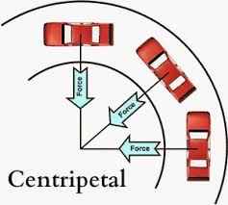



The size of the centripetal force:
- increases with increasing mass of the object
- increase with increasing speed of the object
- decreases with increasing radius of the circle

Centripetal Forces Experiment

A group of students conducted an experiment to investigate the effects of changing the tension mass on the circular velocity of a rubber stopper whilst maintaining a constant radius 0.75 m.

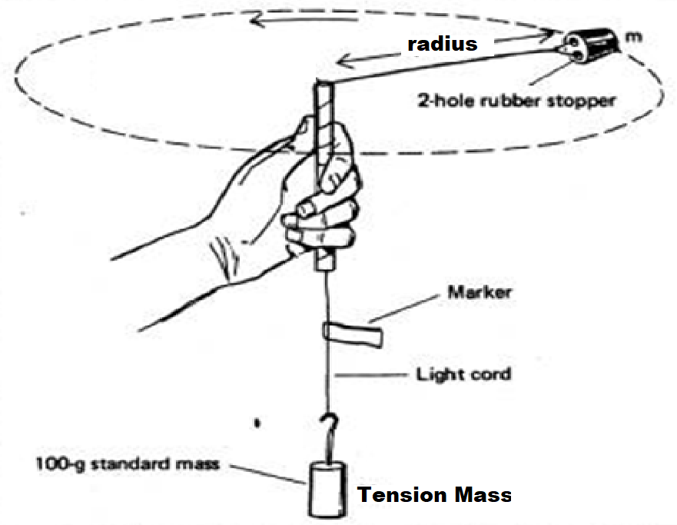

- Identify the following variables
(2 marks)
Independent variable

Dependent variable

Controlled Variables

Results

The table below shows the results achieved by the students during their investigation.

- Conduct the appropriate calculations to complete the table below including units.
(5 marks)

Tension  Mass  (kg) | Tension Force  (mass x gravity)  (N) | No. of revs  in 10 sec | Time for  one rev | Circular  Velocity | Velocity²
0.050 | 0.49 | 8
0.100 | 0..98 | 12
0.150 |  | 14
0.200 |  | 16
0.250 |  | 18

Graph
- Use the axis below to graph Tension force versus Velocity².

(4 marks)

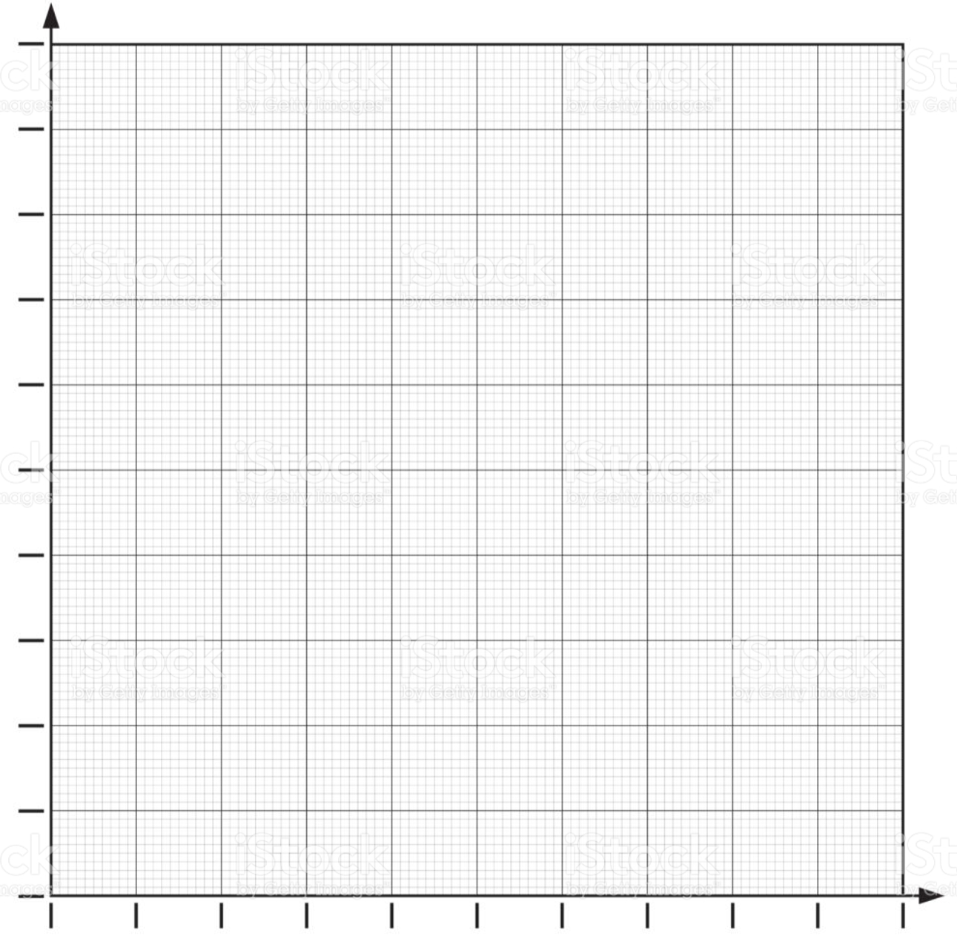

Analysis
- What does the shape of this graph reveal about the relationship the tension force and the square of the velocity?

(2 marks)

- Calculate the gradient of the graph you plotted in question 4.

(3 marks)

- Calculate the mass of the rubber stopper using the following equation.

(2 marks)

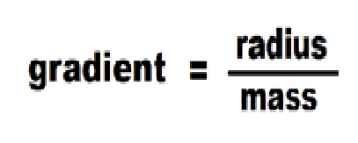

- Use your graph to predict the velocity of the rubber stopper when the tension mass is increased to 4.9 N:
(2 marks)

- If the string breaks when the rubber stopper is travelling in a circular pathway in what direction will the rubber stopper travel? Explain

(2 marks)

- How would the outcome of this experiment be changed if was conducted on the surface of the moon? Explain
(3 marks)

- Briefly explain how you would investigate the affect of changing the stopper mass on the circular velocity. In your explanation include how you would control the variables and record the experimental data.

(5 marks)

